Contact: Bob O’Donnell
TECHnalysis Research, LLC
Phone (650) 224-2355
bob@technalysisresearch.com

Press Release

The Internet of Things Set to Disrupt Structures and Processes in Business

New Study Shows IOT Impacting IT Departments, But Major Challenges Remain
Foster City, CA –April 12, 2016: The widely touted IOT market is starting to have an impact in businesses across the US, but not necessarily in the ways many people have predicted. A recently completed survey of 620 professionals involved with IOT within their respective organizations, conducted by TECHnalysis Research, found that IOT is starting to drive key technologies out of the traditional realm of IT departments and into the arms of companies’ operations groups (sometimes called OT). In fact, 2/3 of all IOT projects in both medium (100-999 employees) and large (1,000+ employees) organizations are managed outside of IT.
Specifically, as the chart below illustrates, about 42% of IOT projects are managed by Operations/Facilities/Manufacturing departments within an organization, another 33% by IT and the remaining 25% by Line of Business or Business Strategy departments.
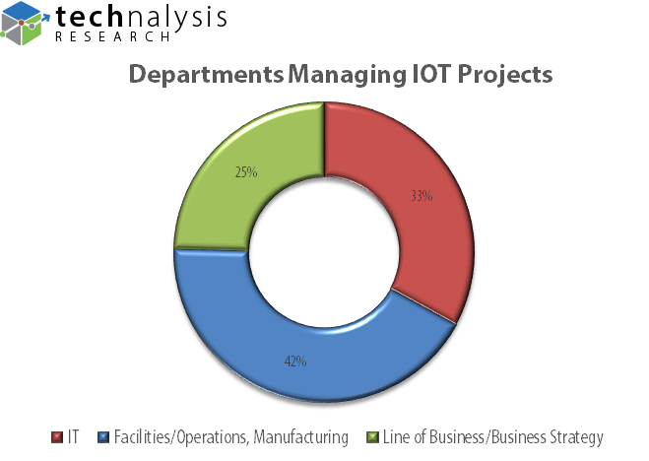
The study also found that 61% of respondents believed IOT is an important or even essential part of their company’s strategies and goals. The clear implication, then, is that IT departments are starting to see the control of critical technologies move outside their direct reach.
“IOT is clearly a key technology and strategy driver for businesses across many industries,” says Bob O’Donnell, President of TECHnalysis Research and author of the study. “Yet it’s equally clear that the integration of IOT projects is starting to shift the center of technological ‘power’ within most organizations outside of IT.”
The primary goal of most IOT projects is changing and improving processes within an organization instead of the more commonly presumed goals of saving or making money. In fact, 43% of projects across the 12 different IOT applications that were studied for the report said their key focus was on improving process quality, while 38% strove to save money and half that amount hoped to make money.
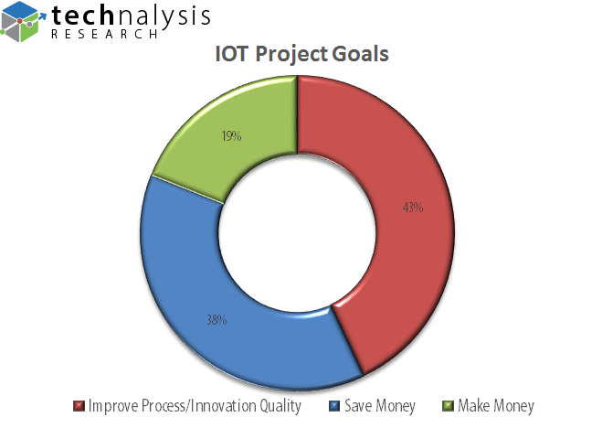
Despite the lofty goals, however, the study also confirmed that many companies are still facing some serious real-world challenges and skepticism around the effectiveness of their efforts. As one survey respondent wrote, “I think what we’re trying to do [with IOT] is very exciting, but I am skeptical if the data that it will produce will be valuable or if it will show the same thing as our old data.”
In addition, when asked about the biggest challenges facing IOT in their organizations, the top choice wasn’t the security of IOT data (that was #3), but the high costs and capital outlays necessary to deploy their IOT projects. The time necessary to test and validate their projects was the second biggest concern, highlighting several of the real-world problems that today’s IOT deployments currently face.
A summary version of the Enterprise IOT report is available in PDF format and can be downloaded for free here. The complete 108-slide version of the report with detailed breakdowns by company, industry and IOT applications is available for purchase. For additional information, please e-mail the author at bob@technalysisresearch.com.
Founded by technology market research veteran Bob O’Donnell, TECHnalysis Research, LLC provides strategic consulting and market research services to the technology industry and professional financial community. Building on a deep understanding of critical technology and business trends, in conjunction with hard-hitting, original research, the firm provides unique "out-of-the-box" perspectives that are still grounded in the practical realities of the technology, media and telecom markets.

